SIGHTSEEINGS OF CHIOS
CHIOS CASTLE
The Castle of Chios is located north in the city center of Chios. It is one of the main attractions of the island and an integral part of the city from both a geographical and a historical perspective. That is why it still consists of an inhabited area to this day, being a living part of Chios city. 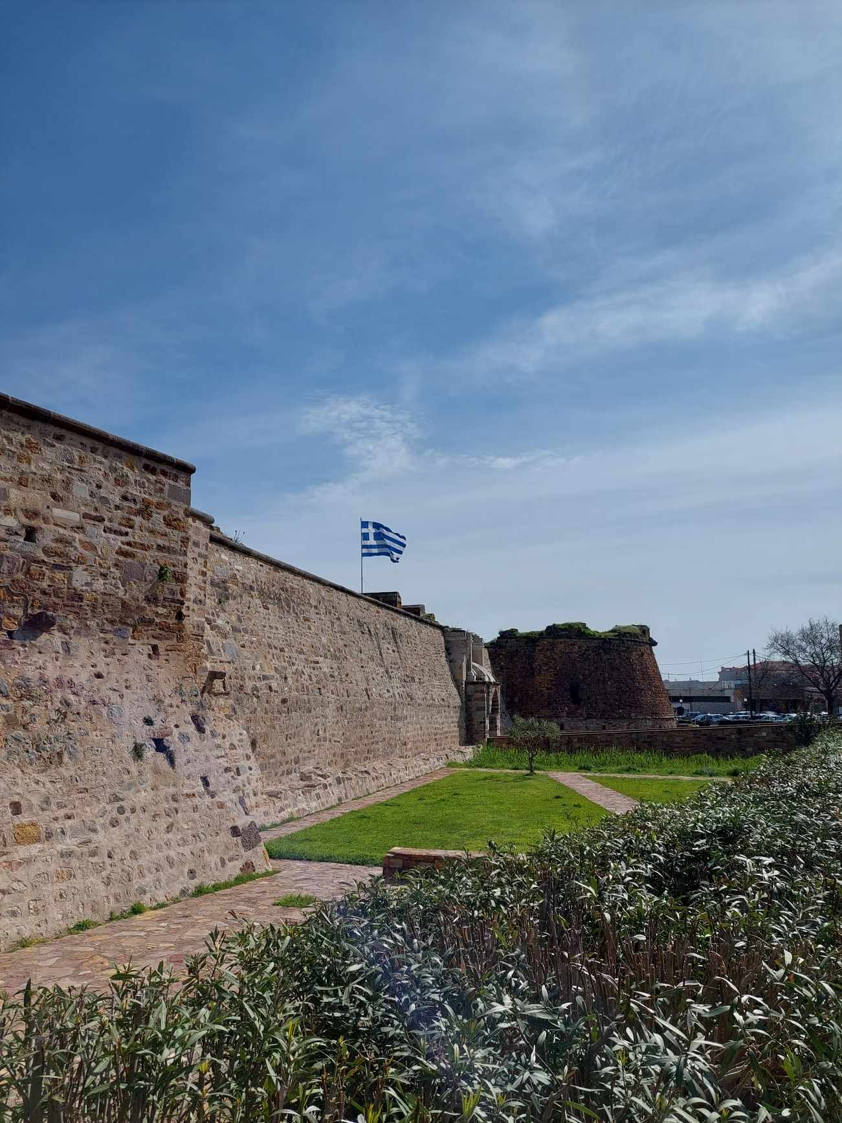
NEA MONI
Nea Moni ("New Monastery") is an 11th century monastery on the island of Chios that has been recognized as a UNESCO World Heritage Site. It is located on the Provateio Oros Mt. in the island's interior, about 15 km from Chios town. It is well known for its mosaics, which, are among the finest examples of "Macedonian Renaissance" art in Greece.
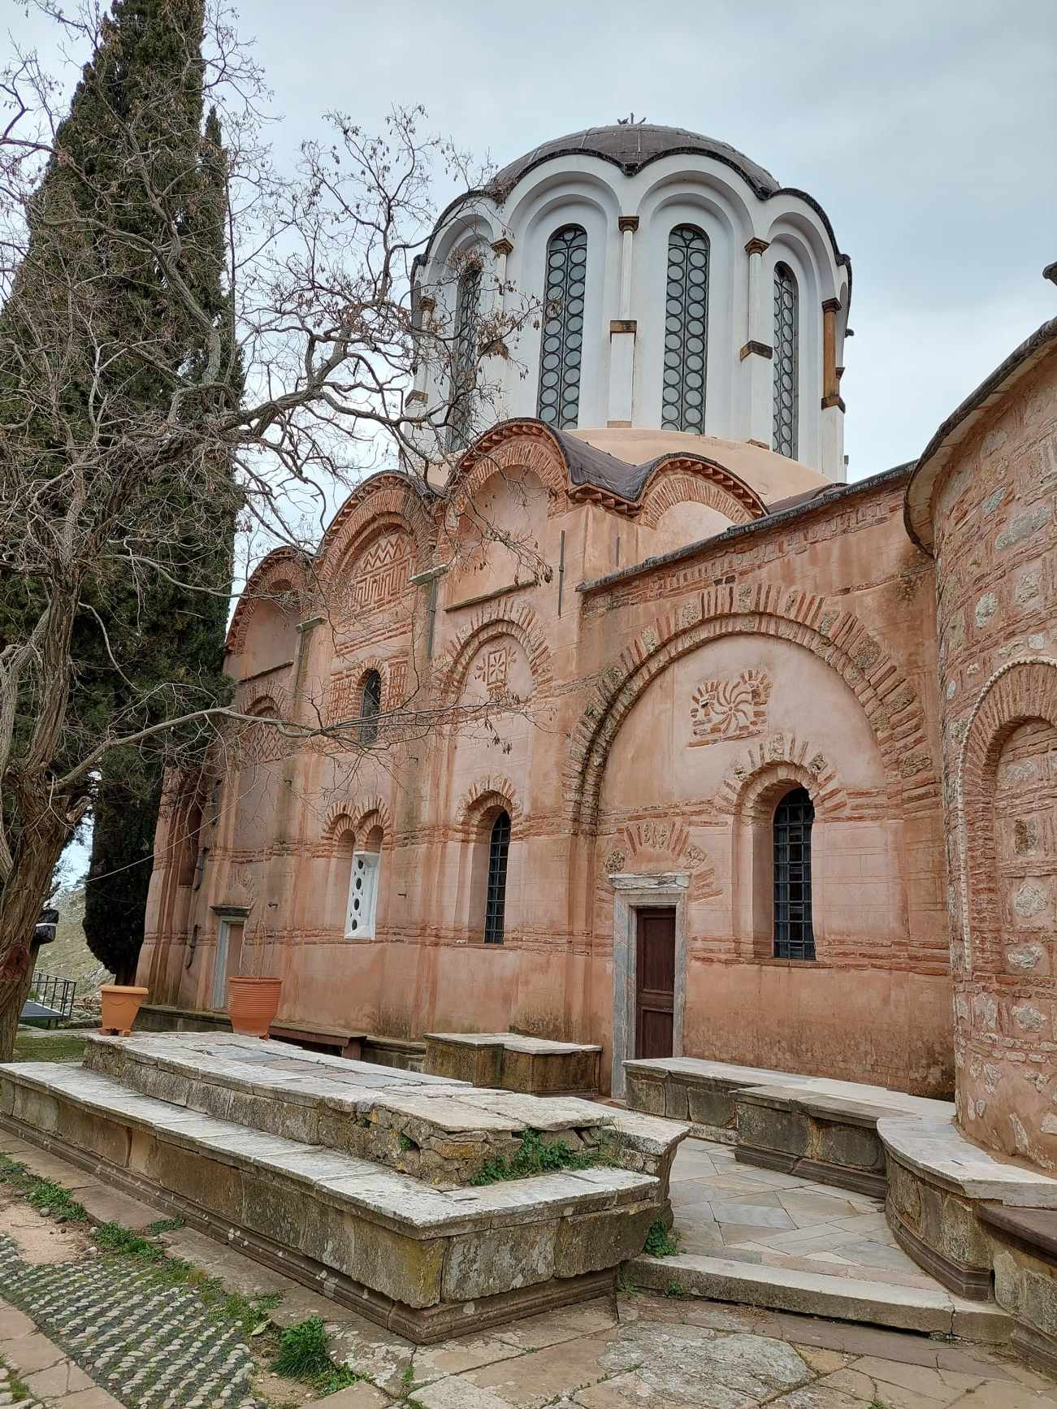

PUBLIC SQUARE
The main Square also known as Vounaki Square is the heart of Chora,the capital of Chios island and is a great place to relax and soak up the island’s vibrant atmosphere. Visitors can sit in one of the cafes, enjoy a cup of coffee, and watch the world go by.
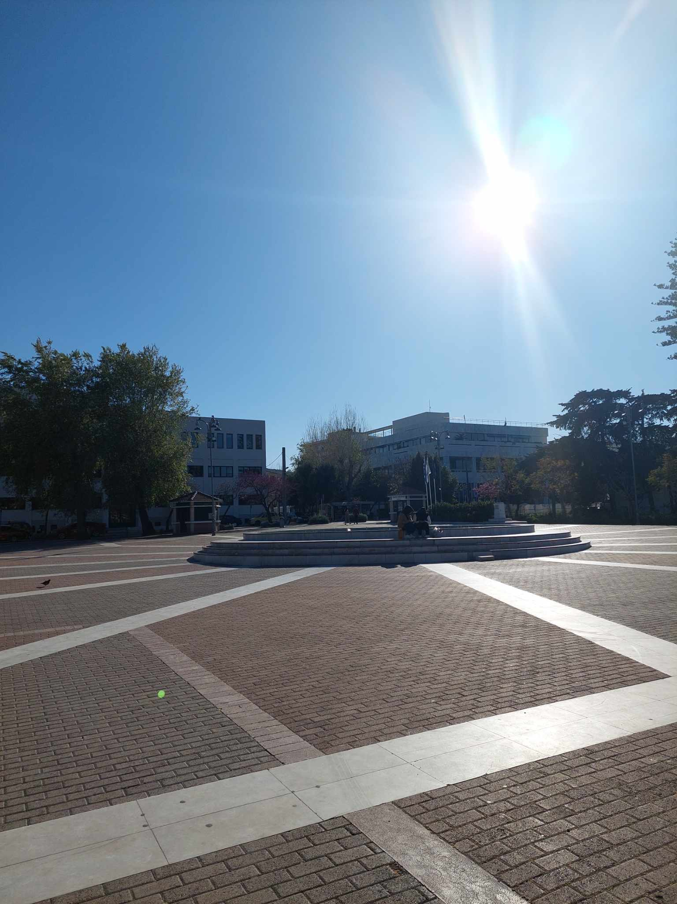

MASTIC VILLAGES
The amazing world of Mastic Villages in Chios (Mastihohória) is a fortified village complex of superb beauty. Villages’ existence relies on the cultivation of the valuable crystal “tear” shed by mastic trees that grow only in the southern part of the island. The Genovese built this complex in order to offer shelter to the families who lived there and cultivated mastic. Some fortress towns are still intact, such as Mesta, Pirgi, Olympi, Kalamoti, Vessa, Patrika, Vouno, Elata and Kini forming impressive medieval settlements
